What is a Web Service?
A Web Service is a method for two software applications to communicate with each other over the internet using standard protocols. It allows applications to exchange data and perform operations, regardless of the programming languages or platforms they are built on.
Ex:-
- SOAP Web Service: Sends XML messages over HTTP.
- REST Web Service: Sends data (often JSON) over HTTP requests.

📦 Spring Boot Application Startup Flow

1. Application Starts
- You run: java -jar myapp.jar
- Spring Boot auto-configures everything (Tomcat, DispatcherServlet, Beans, etc.)

2. Embedded Tomcat Starts
- Spring Boot starts an embedded Tomcat server (default on port 8080)
- It listens for HTTP requests.

3. DispatcherServlet is Registered
- Spring Boot auto-registers DispatcherServlet.
- This servlet is mapped to handle all requests: "/".

4. Request Comes In
- A client (browser or app) sends a request: GET /hello
- Tomcat receives it and passes it to the DispatcherServlet.

5. DispatcherServlet Handles It
- DispatcherServlet checks:
  - Which @Controller or @RestController matches the path (/hello)
  - What method to call (@GetMapping("/hello"))
- It uses HandlerMapping and HandlerAdapter to find and invoke the controller method.

6. Controller Executes
- The controller calls the service or repository layer (if needed).
- Processes logic, fetches or saves data.

7. Response is Returned
- Controller returns the result (e.g., JSON, HTML).
- DispatcherServlet sends it back through Tomcat to the client.

✅ Challenges Solved by Spring Boot

1️⃣ No Need for Manual Servlet or web.xml Configuration
- In traditional Java EE, we had to:
  - Manually declare servlets in web.xml
  - Map URLs, configure filters, etc.
- Spring Boot simplifies this:
  - Uses annotations like @RestController, @GetMapping, etc.
  - Auto-configures servlet settings behind the scenes.

2️⃣ Built-in JSON Support with Jackson
- Previously, we had to:
  - Manually configure JSON converters and dependencies.
- In Spring Boot:
  - JSON support is auto-configured using Jackson.
  - Just use @RequestBody and @ResponseBody to handle JSON effortlessly.

3️⃣ Inversion of Control (IoC) and Dependency Injection (DI)
- You define classes and dependencies, and Spring handles the rest:

🔄 What Spring does:
- Scans for annotated classes like:
  - @Component, @Service, @Repository, @Controller
- Creates objects (Beans) and puts them in the IoC container (ApplicationContext)
- When a class needs a bean:
  - Spring injects it automatically
  - Use @Autowired or constructor injection

4️⃣ Simplified Unit Testing
- Thanks to DI:
  - Beans are easily mockable.
  - Dependencies are injected automatically.
- Makes unit testing easier and cleaner.

5️⃣ Auto-Configuration
- Spring Boot provides out-of-the-box configuration for:
  - DispatcherServlet
  - @ComponentScan
  - Embedded Tomcat server
- Reduces boilerplate and saves development time.

What is Maven?
Maven is a tool that helps you manage project dependencies, build your code, and automate project lifecycle tasks like testing, packaging, and deployment

Layered Architecture in Spring Boot

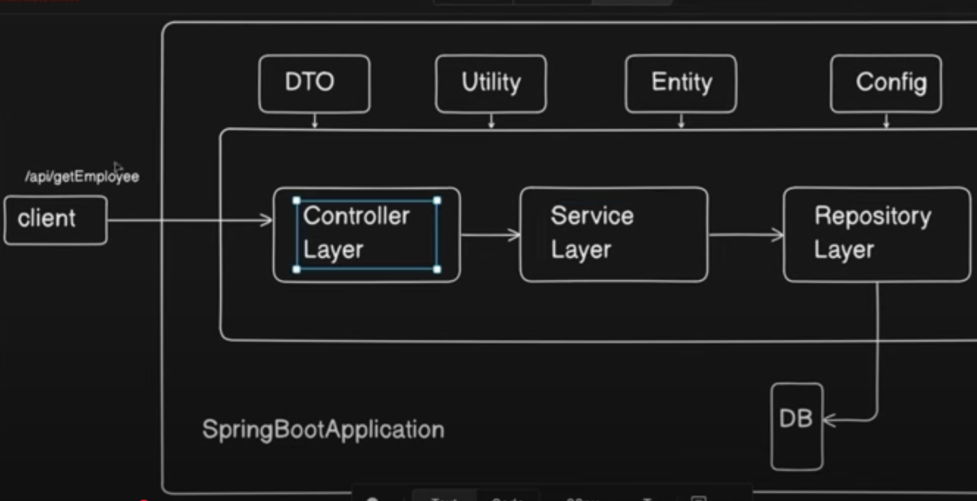

1. Presentation Layer (Controller Layer)
- Purpose: Handles HTTP requests and returns responses.
- Use @RestController or @Controllerannotations.
- @Controller: Used for returning views (like HTML or JSP) in traditional web applications.
- @RestController: Used for returning data (usually in JSON) in RESTful web services and APIs.

2. Service Layer
- Purpose: Contains the business logic of the application.
- Responsibilities:
  - Manages transactions and business rules.
  - Calls methods from the repository layer and processes the data.
  - Typically annotated with @Service.

3. Persistence Layer (Repository Layer)
- Purpose: Interacts with the database to perform CRUD (Create, Read, Update, Delete) operations.
- Responsibilities:
  - Manages data access logic.
  - Typically uses Spring Data JPA or JDBC for database operations.
  - Annotated with @Repository.
  - Spring Data provides methods like findById(), save(), etc.

4.Entity
An Entity represents a table in the database. It is a Java class that is mapped to a database table using JPA (Java Persistence API).
5.DTO (Data Transfer Object)
To transfer data between different layers, such as between the Service Layer and Controller Layer.

Spring boot anotations

What is a Bean
In Spring, a Bean is simply an object that is managed by the Spring IoC (Inversion of Control) container.
- Any object created, configured, and managed by Spring is called a Bean.
- Beans are typically service classes, repositories, controllers, or any custom components.
- They are defined in the application context and injected where needed using Dependency Injection (DI).

How to Create a Bean (Using @Component Annotation)
You can define a class as a Bean using @Component. Spring will automatically detect and manage it during component scanning.

@Component
public class MyService {
public void serve() {
System.out.println("Serving...");
}
}
- The @Component annotation marks the class as a candidate for auto-detection.
- You can inject it using @Autowired or constructor injection.
Other specializations of @Component:
- @Service – for service classes
- @Repository – for data access
- @Controller – for web controllers

How to Create Bean (Using @Bean and @Configuration Annotations)
Another way to define beans is using Java configuration with @Configuration and @Bean.

@Configuration
public class AppConfig {

@Bean
public MyService myService() {
return new MyService();
}
}

- @Configuration tells Spring this class contains bean definitions.
- @Bean tells Spring to create and manage the returned object as a Bean.

🔹 @Component
- Used on classes
- Spring automatically detects it during component scanning
- Spring creates an object (bean) of that class
- No need to write any configuration manually
Example:

@Component
public class MyService {
public void serve() {
System.out.println("Serving...");
}
}

🔹 @Bean
- Used on methods inside a @Configuration class
- You manually define and return the object you want Spring to manage
- Gives you more control over bean creation (e.g., third-party library objects)
Example:

@Configuration
public class AppConfig {

@Bean
public MyService myService() {
return new MyService();
}
}

🔹 What is IoC Container in Spring?
IoC stands for Inversion of Control, and the IoC container is the core part of the Spring Framework that:
✅ Creates objects (beans)
✅ Manages their lifecycle
✅ Handles dependencies between them (Dependency Injection)

🧠 Think of the IoC container as:
"A smart factory that creates and manages objects for you."

🔸 How It Works:
- You annotate your classes with:
  - @Component, @Service, @Repository, or @Controller
- Spring scans those classes during startup
- Spring creates objects (beans) of those classes
- Spring stores them inside the IoC container
- Whenever another class needs one of those beans, Spring injects it automatically

What is Dependency Injection (DI)?
Definition:
Dependency Injection is a design pattern used to remove tight coupling between classes by allowing an external system (like Spring) to provide dependencies rather than a class creating them itself.

✅ Q: How does Spring implement Dependency Injection?
Answer:
Spring uses the IoC container (ApplicationContext) to create, manage, and inject beans using annotations like @Autowired, @Component, @Service, and @Controller.

✅ Q: What are the types of Dependency Injection in Spring?
Answer:
- Constructor Injection (Recommended)
- Field Injection
- Setter Injection

✅ Q: Which injection is preferred in Spring?
Answer:
Constructor Injection is preferred because it makes dependencies mandatory, supports immutability, and is easier to test.

✅ Q: What is the role of @Autowired?
Answer:
@Autowired tells Spring to inject a bean automatically where it's required. It can be used on constructors, fields, or setter methods.

✅ Q: What are the benefits of Dependency Injection?
Answer:
- Loose coupling
- Better code reusability
- Easy unit testing
- Easier to manage complex applications

✅ What is Bean Scope in Spring?
Bean scope defines how many instances of a bean Spring should create and how long they should live.

✅ What are the common Bean Scopes?
Scope | Description | Use Case
Singleton | One instance per Spring container (default) | Shared services
Prototype | New instance every time it’s requested | Stateful beans
Request | One instance per HTTP request (web only) | REST controllers
Session | One instance per HTTP session (web only) | Shopping cart

🎯 Why do we need @Qualifier?
If you have more than one bean of the same type, Spring doesn't know which one to inject, so you must tell it specifically which one to use.

✅ SOLID Principles (5 Core Design Principles)

1️⃣ S – Single Responsibility Principle (SRP)
A class should have only one responsibility or class should have one resason to change

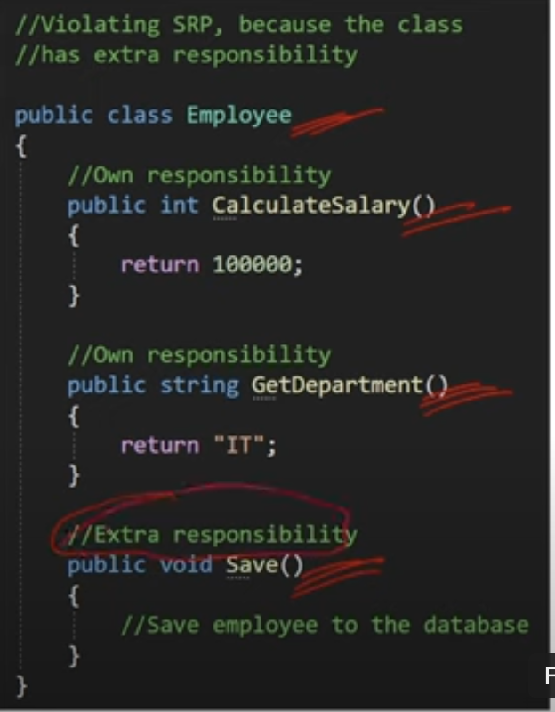
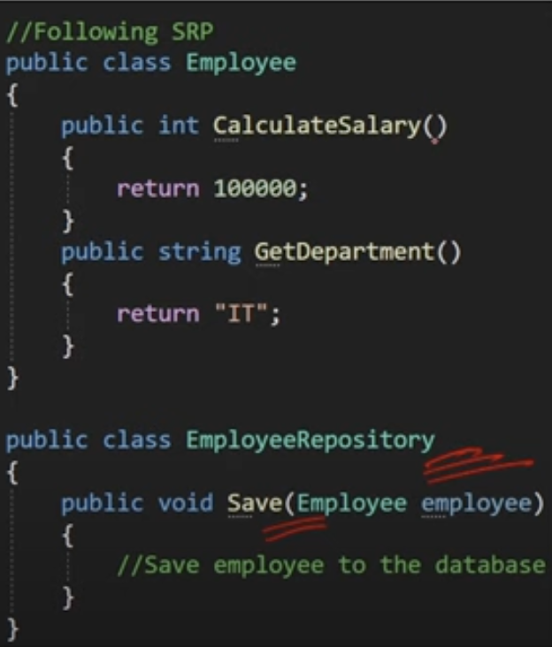

🧪 Example:
In a Spring app, keep business logic in @Service, and data access logic in @Repository—don’t mix them.

2️⃣ O – Open/Closed Principle (OCP)
Software entities(class,modules) should be open for extension but closed for modification.

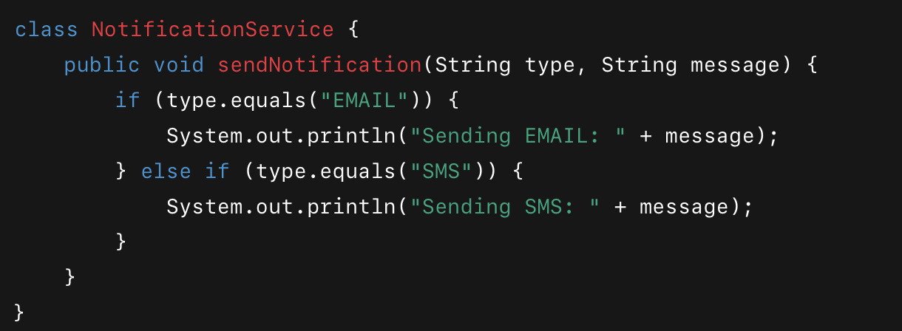

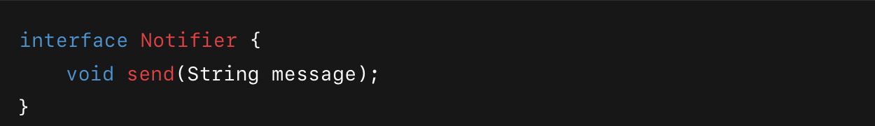
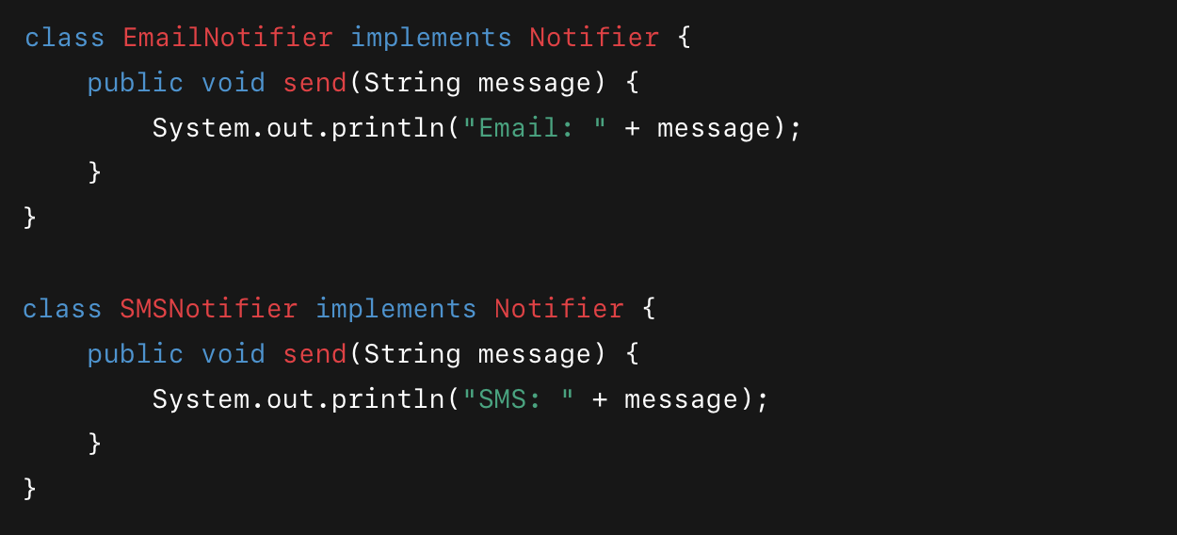
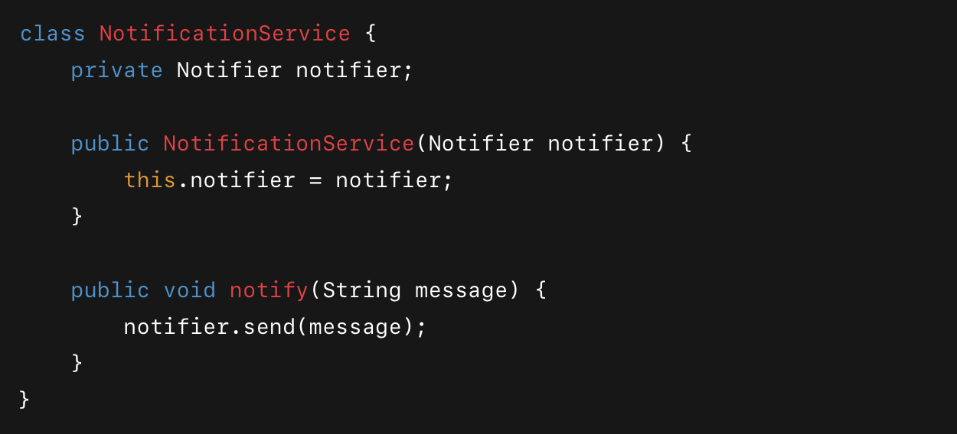

NotificationService n=new NotificationService(new smsNofier());
n.send(“Hello”);

🧪 Example:
Use interfaces and inheritance. You can add a new implementation of a service without modifying the existing one.

3️⃣ L – Liskov Substitution Principle (LSP)
Any subclass object should be able to replace a parent class object without affecting the correctness of the program.
🧪 Example:
If you have PaymentService interface, any class implementing it (like CreditCardPaymentService or PaypalPaymentService) should work without breaking functionality.

4️⃣ I – Interface Segregation Principle (ISP)
Clients should not be forced to depend on interfaces they do not use.
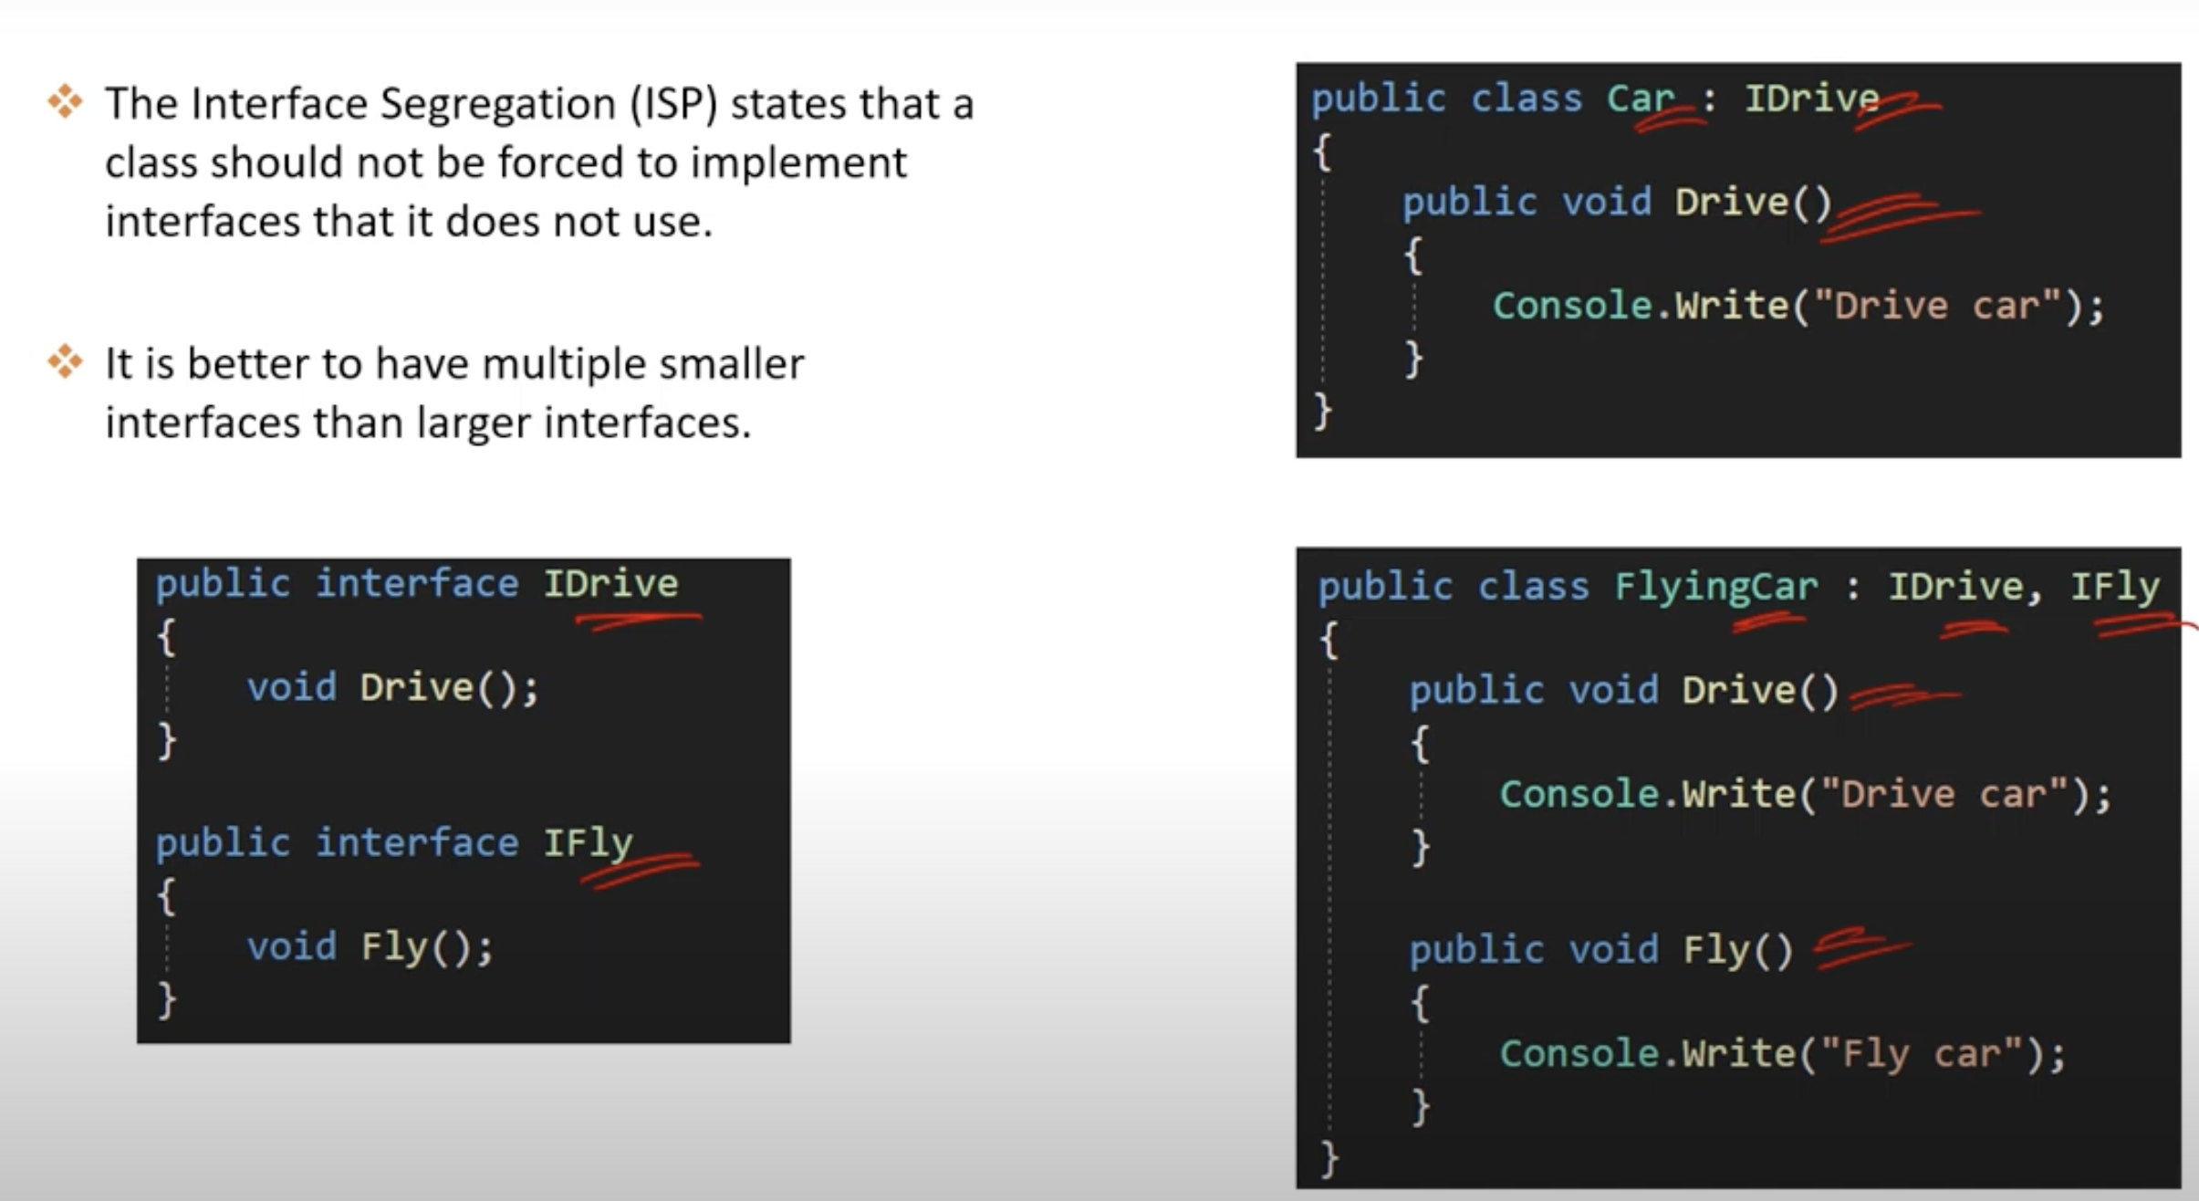

🧪 Example:
Instead of one big UserService interface with 10 methods, create smaller ones like UserReader, UserWriter.

5️⃣ D – Dependency Inversion Principle (DIP)
High-level modules should not depend on low-level modules. Both should depend on abstractions.
📌 Code should depend on interfaces, not concrete classes.
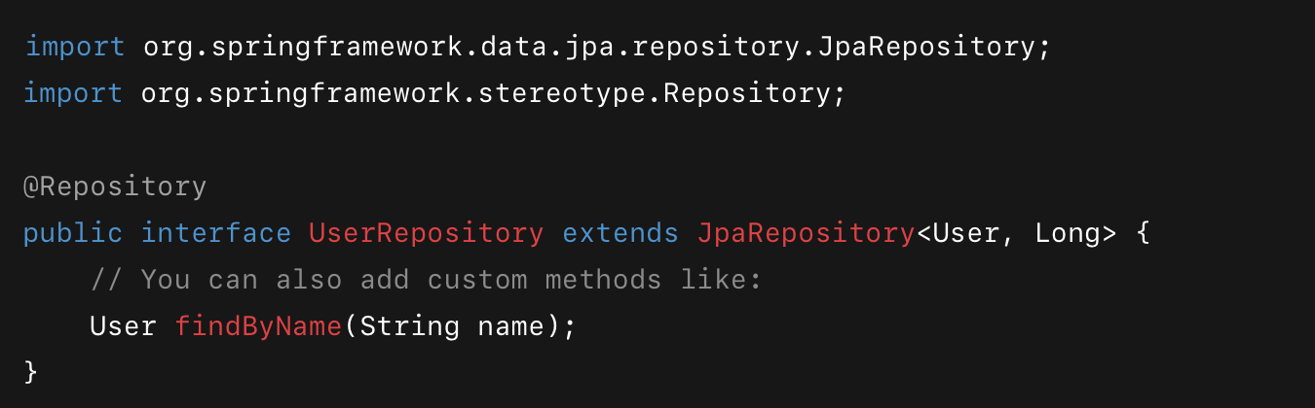

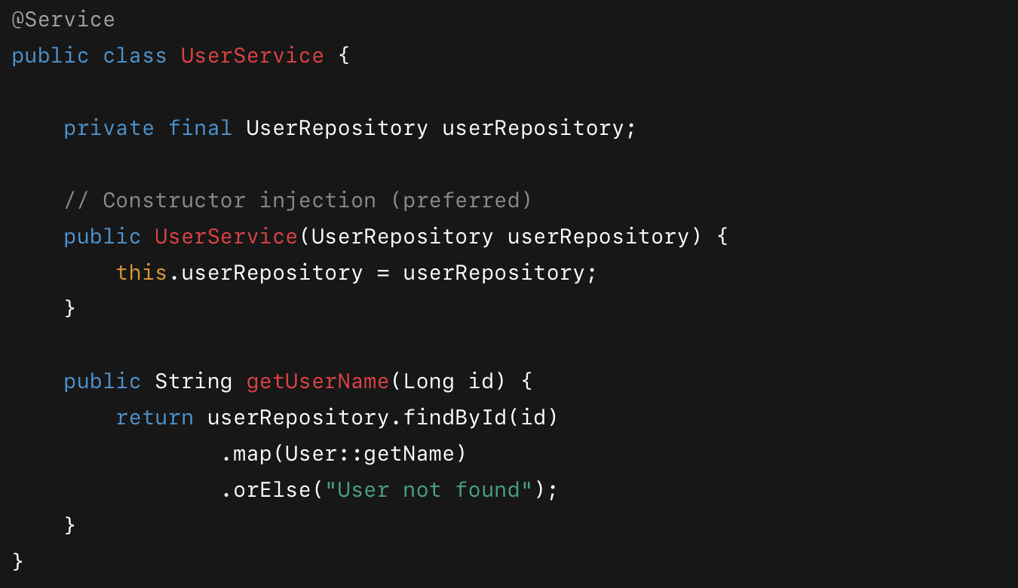

🧪 Example:
In Spring, you often use interfaces + @Autowired, and Spring injects the implementation—this is DIP in action!

